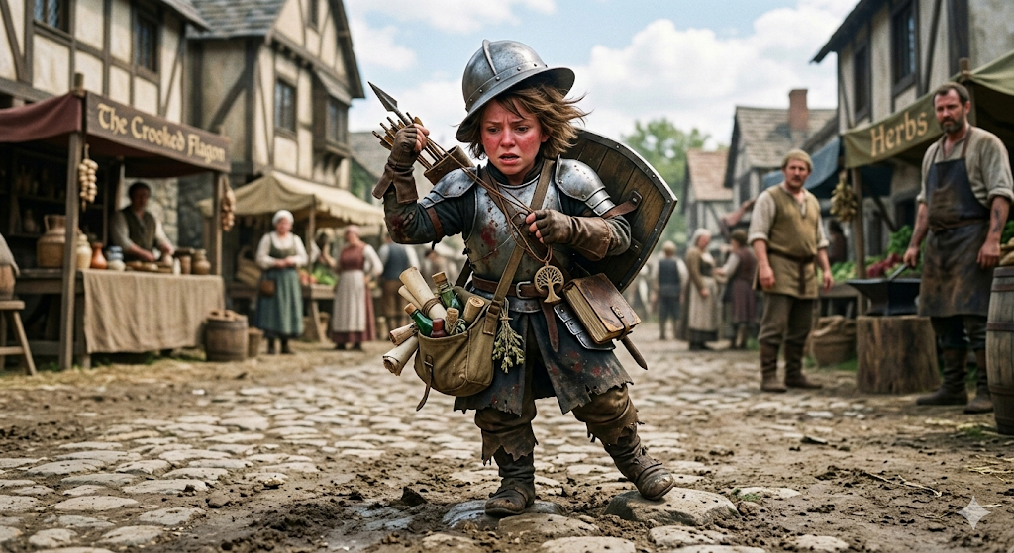
Jube Curnow
Small Humanoid (female Ghostwise Halfling), Lawful Neutral
The Cleric who is considered the worst in her profession.
Personality Trait Disorganized
Armor Class 17 (splint)
Hit Points 7 (3d6 - 3)
Speed 15 ft
STR 11(+0) DEX 18(+4) CON 8(-1) INT 10(+0) WIS 11(+0) CHA 10(+0)
STR | DEX | CON | INT | WIS | CHA
11 (+0) | 18 (+4) | 8 (-1) | 10 (+0) | 11 (+0) | 10 (+0)

Saving Throws Wis +2, Cha +2
Skills Deception +2, Insight +2, Medicine +2
Senses passive Perception 10
Languages Common, Halfling
Proficiency +2
Challenge 1 (200 XP)
TRAITS
Brave. Jube has advantage on saving throws against being frightened.
Nimble. Jube can move through the space of any Medium or larger creature.
Lucky. When Jube rolls a 1 on an attack roll, ability check, or saving throw, she can reroll the die. Jube must use the new result, even if it is a 1.
Silent Speech. Jube can speak telepathically inside the mind of a creature within 30 feet of her. The creature understands her if both share a language.
Disciple of Life. Whenever Jube uses a spell to restore hit points to a creature, the creature regains 3 additional hit points.
Stealth Disadvantage. Jube has disadvantage on Dexterity (Stealth) checks while wearing her Splint armor.
ACTIONS
Javelin. Melee or Ranged Weapon Attack: +2 to hit, reach 5 ft or range 30/120 ft, one target. Hit: 3 (1d6) piercing damage.
Spellcasting. Jube casts one of the following spells, using Wisdom as the spellcasting ability (spell save DC 10, +2 to hit with spell attacks):
At will: spare the dying, thaumaturgy, resistance
2/day each: burning hands, cure wounds, bless

Jube Curnow: The "Walking Liability"
Jube Curnow is a bit of a local legend, though for all the wrong reasons. A Ghostwise Halfling who stands barely three feet tall, she is encased in an oversized suit of clanking splint mail that she clearly hasn't polished—or fully strapped on—in weeks.
While she possesses the divine spark of a Life Domain cleric, her execution is... lacking. She’s the person who accidentally telepathically broadcasts her internal grocery list while trying to deliver a sermon.

Roleplaying Jube
- The Clatter: Jube doesn't walk; she rattles. Between her low Strength and her heavy armor, she is constantly tripping over uneven cobblestones or her own greaves.
- Telepathic Tics: She often forgets to use her actual voice. You’ll be mid-conversation when her voice suddenly pops into your brain: "Wait, did I leave the incense burning? Also, hello."
- The "Worst" Cleric: It’s not that she’s evil; she’s just profoundly disorganized. She forgets the words to prayers, loses her holy symbol in her many pockets, and her 15-foot movement speed means she usually arrives at the scene of an injury just as the patient has finished healing naturally.

Notable Stats & Quirks
Feature | Detail
Glass Cannon (Minus the Cannon) | With only 2 HP, a stiff breeze or a particularly aggressive sneeze could send Jube to see her deity.
The Splint Paradox | Despite her 18 Dexterity, she wears heavy splint armor that negates her stealth and slows her to a crawl. She insists it’s for "safety."
Efficient Healing | Ironically, if she actually manages to reach you, her Disciple of Life trait makes her Cure Wounds surprisingly effective. You just have to survive long enough for her to get there.

Adventure Hooks
- The Escort Mission from Hell: A local temple is desperate to get Jube to a distant shrine—mostly to get her out of their hair. They hire the party to ensure she doesn't trip and die on a pebble during the three-day journey.
- The Silent Witness: Jube telepathically witnessed a crime, but she’s so disorganized that her "testimony" is a jumbled mess of mental images of half-eaten sandwiches and the color blue.
- The Lucky Fluke: Despite her stats, Jube’s Lucky trait means she occasionally survives encounters she has no business winning, leading some to believe she is secretly a chaotic saint.
Jube's Motto: "I'm coming! Just... give me a minute. Or ten. Does anyone have a bandage? I think I sat on my javelin."

A portrait of Jube Curnow, a Ghostwise Halfling Cleric. She is short, standing around three feet, but appears much bulkier due to her heavy, poorly fitted splint mail armor, which is dull grey and mismatched. Her expression is one of slight panic and intense focus as she stumbles forward with a 15-foot movement speed.
She has short, tousled brown hair that is messy and sticking out from under a too-large helmet that is perpetually tilted. In one hand, she clutches a javelin awkwardly, not quite gripping it correctly. Her other hand fumbles with a wooden holy symbol of her deity, which hangs on a tangled cord around her neck, partially obscured by the straps of her armor.
A small, open satchel at her waist is clearly disorganized, with scrolls, vials, and crumbs spilling out. Her gaze is not on the viewer but slightly off to the side, perhaps trying to remember the verbal components of a spell. The setting is a dirt path near a village, and she looks like she's about to trip over a small rock.

